**Ethical Hacking 101**

Hacking is a broad term that refers to the unauthorized access, modification, or manipulation of computer systems, networks, or software applications. It encompasses a range of activities, from exploration and experimentation to malicious attacks aimed at gaining unauthorized access or causing damage.

**What is Ethical hacking?**

Ethical hacking, also known as penetration testing or white-hat hacking, refers to the practice of deliberately testing computer systems, networks, and applications to find security vulnerabilities that a malicious hacker could exploit. Ethical hackers use their skills and knowledge to assess the security posture of an organization's systems, often with the permission and knowledge of the organization, to identify weaknesses before malicious hackers can exploit them.

The primary goal of ethical hacking is to improve the security of the systems and networks by fixing the vulnerabilities found during the assessment. Ethical hackers follow a code of ethics and conduct, ensuring that they operate within legal boundaries and with the explicit consent of the system owners. Their activities are aimed at helping organizations strengthen their overall security measures and protect against cyber threats.

Ethical hacking involves various techniques and methodologies, including:

1. Vulnerability Assessment: Identifying and assessing vulnerabilities in systems and networks.
2. Penetration Testing: Attempting to exploit vulnerabilities to determine the effectiveness of existing security measures.
3. Social Engineering Testing: Assessing the susceptibility of personnel to social engineering attacks.
4. Wireless Network Testing: Evaluating the security of wireless networks.
5. Web Application Testing: Identifying vulnerabilities in web applications and services.

Overall, ethical hacking plays a crucial role in proactive cybersecurity, helping organizations preemptively secure their systems and data from malicious actors.

**Importance of ethical hacking**

Ethical hacking is important for several reasons, primarily centered around enhancing cybersecurity and protecting organizations from malicious attacks. Here are some key reasons why ethical hacking is valuable:

1. Identifying Vulnerabilities: Ethical hackers help organizations identify and understand vulnerabilities in their systems, networks, and applications. By uncovering these weaknesses, organizations can take proactive steps to fix them before malicious hackers exploit them for nefarious purposes.
2. Improving Security Posture: Through ethical hacking, organizations can assess their overall security posture. This process helps in strengthening defenses, implementing better security controls, and ensuring that sensitive data and systems are adequately protected.
3. Compliance and Regulations: Many industries and jurisdictions have regulatory requirements for cybersecurity. Ethical hacking helps organizations meet these compliance standards by identifying gaps and vulnerabilities that need to be addressed to stay compliant.
4. Risk Management: Ethical hacking contributes to effective risk management by providing insights into potential security risks. Organizations can prioritize and allocate resources to mitigate high-risk vulnerabilities, reducing the likelihood of security incidents and their impact.
5. Educating Personnel: Ethical hacking exercises often involve testing the awareness and response of organizational personnel to simulated attacks. This helps in raising awareness about cybersecurity best practices and training employees to recognize and respond to potential threats effectively.
6. Preventing Data Breaches: By proactively identifying and fixing vulnerabilities, ethical hacking reduces the risk of data breaches. This protects sensitive information, such as customer data, intellectual property, and financial records, from unauthorized access and exploitation.
7. Building Trust: Engaging in ethical hacking demonstrates a commitment to security and proactive risk management. It builds trust among customers, partners, and stakeholders who rely on the organization to protect their information and assets.

Overall, ethical hacking serves as a critical component of a comprehensive cybersecurity strategy. It provides organizations with the necessary insights and tools to stay ahead of evolving cyber threats and maintain a robust defense against malicious activities.

**Career Paths and Employment opportunities in Ethical hacking**

1. Penetration Tester (Pen Tester):
   * Job Description: Conduct security assessments of systems, networks, and applications to find vulnerabilities.
   * Skills Needed: Strong understanding of networking, operating systems, and security concepts. Proficiency in using hacking tools and techniques.
   * Certifications: CEH (Certified Ethical Hacker), OSCP (Offensive Security Certified Professional), CISSP (Certified Information Systems Security Professional).
2. Security Consultant:
   * Job Description: Advise organizations on how to improve their security posture. Conduct risk assessments and help implement security measures.
   * Skills Needed: Broad knowledge of cybersecurity, including governance, risk management, and compliance (GRC) frameworks.
   * Certifications: CISSP, CISM (Certified Information Security Manager), CISA (Certified Information Systems Auditor).
3. Incident Response Analyst:
   * Job Description: Investigate and respond to cybersecurity incidents. Analyze the impact and help recover from security breaches.
   * Skills Needed: Forensics analysis, understanding of malware behavior, incident handling procedures.
   * Certifications: GCIH (GIAC Certified Incident Handler), GCFA (GIAC Certified Forensic Analyst), EnCE (EnCase Certified Examiner).
4. Security Researcher:
   * Job Description: Discover new vulnerabilities and develop exploits. Often involves working for security firms or independent research.
   * Skills Needed: Strong programming skills, deep understanding of system internals and security mechanisms.
   * Certifications: None specific, but academic background in computer science or cybersecurity is valuable.
5. Security Architect:
   * Job Description: Design secure systems and networks. Develop security policies and best practices.
   * Skills Needed: Expertise in architecture principles, threat modeling, and secure design patterns.
   * Certifications: CISSP, SABSA (Sherwood Applied Business Security Architecture).

Employment Opportunities:

* Government Agencies: Many government bodies hire ethical hackers to secure sensitive information and critical infrastructure.
* Private Companies: Tech companies, financial institutions, healthcare providers, and other industries need ethical hackers to protect their data and systems.
* Security Firms: Consulting firms specializing in cybersecurity often employ ethical hackers to perform penetration testing and security assessments for clients.
* Freelancing: Some ethical hackers work independently or as freelancers, offering penetration testing services on a contract basis.
* Academia and Training: Opportunities exist for ethical hackers to teach, train, or develop educational content related to cybersecurity.

Tips for Success:

* Continuous Learning: The field of cybersecurity evolves rapidly, so staying updated with the latest tools, techniques, and vulnerabilities is crucial.
* Networking: Building a network of contacts within the cybersecurity community can provide job opportunities and professional growth.
* Hands-on Experience: Employers often value practical experience, so participating in capture-the-flag (CTF) competitions, bug bounty programs, or open-source projects can be beneficial.
* Certifications: While not always mandatory, certifications can demonstrate your expertise and commitment to the field.

Ethical hacking offers a dynamic and challenging career path with opportunities to make a significant impact in protecting digital assets from cyber **threats.**

**Top of Form**

**Bottom of Form**

**Legal and Ethical Considerations in Ethical hacking**

Legal Considerations:

1. Authorization: Ethical hackers must obtain explicit authorization from the organization or individual responsible for the systems being tested. This is typically documented in a legal agreement or contract outlining the scope, limitations, and rules of engagement for the testing.
2. Compliance: Ethical hacking activities must comply with applicable laws, regulations, and contractual obligations. This includes data protection laws (e.g., GDPR, CCPA), industry standards (e.g., PCI DSS for payment card data), and organizational policies.
3. No Damage: Ethical hackers must not cause damage to the systems or networks being tested. Activities should be limited to identifying and exploiting vulnerabilities to demonstrate their existence without disrupting operations or causing data loss.
4. Confidentiality: Ethical hackers must maintain the confidentiality of any sensitive information discovered during testing. This includes not disclosing vulnerabilities or sensitive data to unauthorized parties and following guidelines for handling and storing such information securely.
5. Reporting: Ethical hackers are responsible for documenting their findings accurately and promptly reporting vulnerabilities to the organization’s designated point of contact. Detailed reports typically include descriptions of vulnerabilities, their potential impact, and recommended remediation steps.

Ethical Considerations:

1. Integrity: Ethical hackers should conduct themselves with integrity and professionalism. They should adhere to ethical guidelines and standards of conduct, acting in good faith to improve security rather than exploit vulnerabilities for personal gain.
2. Minimize Harm: Ethical hackers should minimize the risk of disruption or harm to systems and data during testing. This includes using techniques and tools responsibly and avoiding actions that could adversely affect the availability or integrity of services.
3. Informed Consent: Organizations and individuals should be fully informed about the scope, purpose, and potential risks of ethical hacking activities before giving consent. This ensures transparency and helps manage expectations regarding the outcomes of testing.
4. Continuous Learning: Ethical hackers should continually update their skills and knowledge to keep pace with evolving cybersecurity threats and techniques. This includes staying informed about new vulnerabilities, tools, and best practices in ethical hacking.

By adhering to these legal and ethical considerations, ethical hackers can effectively contribute to improving cybersecurity posture while demonstrating respect for privacy, confidentiality, and lawful conduct. This approach helps build trust between security professionals and organizations, fostering a collaborative effort to protect against malicious threats.

**Top of Form**

**Bottom of Form**

**Types of Hackers**

A Hacker is a person who is intensely interested in the mysterious workings of any computer operating system. Hackers are most often programmers. They gather advanced knowledge of operating systems and programming languages and discover loopholes within systems and the reasons for such loopholes.

There are majorly three types of hackers, and generally 10 types of Hackers, which are:

* **White Hat Hackers:** White hat hackers are the one who is authorized or the certified hackers who work for the government and organizations by performing penetration testing and identifying loopholes in their cybersecurity. They also ensure the protection from the malicious cybercrimes. They work under the rules and regulations provided by the government, that’s why they are called *Ethical hackers* or *Cybersecurity experts*.
* **Black Hat Hackers:** They are often called *Crackers*. Black Hat Hackers can gain the unauthorized access of your system and destroy your vital data. The method of attacking they use common hacking practices they have learned earlier. They are criminals and can be easily identified because of their malicious actions.
* **Gray Hat Hackers:** Gray hat hackers fall somewhere in the category between white hat and black hat hackers. They are not legally authorized hackers. They work with both good and bad intentions; they can use their skills for personal gain. It all depends upon the hacker. If a gray hat hacker uses his skill for his personal gains, he/she is considered as black hat hackers.
* **Script Kiddies:** They are the most dangerous people in terms of hackers. A Script kiddie is an unskilled person who uses scripts or downloads tools available for hacking provided by other hackers. They attempt to attack computer systems and networks and deface websites. Their main purpose is to impress their friends and society. Generally, Script Kiddies are juveniles who are unskilled about hacking.
* **Green Hat Hackers:** They are also amateurs in the world of hacking, but they are bit different from script kiddies. They care about hacking and strive to become full-blown hackers. They are inspired by the hackers and ask them few questions about. While hackers are answering their question they will listen to its novelty.
* **Blue Hat Hackers:**They are much like the white hat hackers; they work for companies for security testing of their software right before the product launch. Blue hat hackers are outsourced by the company unlike white hat hackers which are employed by the (part of the) company.
* **Red Hat Hackers:** They are also known as the eagle-eyed hackers. Like white hat hackers, red hat hackers also aim to halt the black hat hackers. There is a major difference in the way they operate. They become ruthless while dealing with malware actions of the black hat hackers. Red hat hacker will keep on attacking the hacker aggressively that the hacker may know it as well have to replace the whole system.
* **State/Nation Sponsored Hackers:** State or Nation sponsored hackers are those who are appointed by the government to provide them cybersecurity and to gain confidential information from other countries to stay at the top or to avoid any kind of danger to the country. They are highly paid government workers.
* **Hacktivist:** These are also called the online versions of the activists. Hacktivist is a hacker or a group of anonymous hackers who gain unauthorized access to government’s computer files and networks for further social or political ends.
* **Malicious Insider or Whistleblower**: A malicious insider or a whistleblower could be an employee of a company or a government agency with a grudge or a strategic employee who becomes aware of any illegal activities happening within the organization and can blackmail the organization for his/her personal gain.

**5 Stages/Phases of Ethical Hacking of Ethical**

Ethical hacking involves simulating attacks to evaluate and assess the security of a system or network. The primary goal is to discover any vulnerabilities or weaknesses and offer suggestions for enhancing security. Ethical hacking plays a crucial role in contemporary cybersecurity by enabling organizations to detect and mitigate security risks proactively, preventing potential exploits by malicious actors.

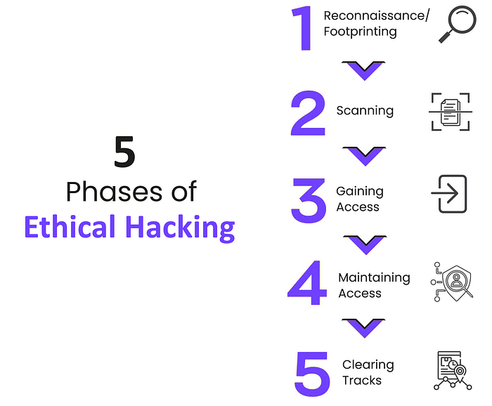

This blog post explores the five phases of ethical hacking: reconnaissance/footprinting, scanning, gaining access, maintaining access, and covering tracks. Within each phase, an in-depth analysis is conducted on the methodologies and specialized tools utilized by ethical hackers.

**Phase 1: Reconnaissance/Footprinting:**

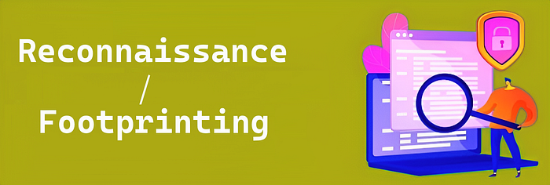

Reconnaissance, often denoted as “Footprinting” in ethical hacking, constitutes the initial phase of a systematic data-gathering process. In this phase, security professionals meticulously acquire information and intelligence pertaining to a target system, network, or entity. This process involves the methodical collection of publicly accessible data, facilitating an in-depth comprehension of the target’s technological infrastructure, system architecture, and potential security vulnerabilities. The primary objective at this stage is to construct a comprehensive profile of the target, enabling security professionals to pinpoint potential entry points for subsequent penetration testing or security evaluations. *This gathered intelligence serves as a critical foundation for the precise planning and execution of ethical hacking endeavors*.

**Methods Employed in Phase 1:**

1. **Passive Information Gathering:** This involves collecting data about the target without directly interacting with it. It includes activities such as searching for publicly available information on websites, social media, forums, and search engines.
2. **Active Information Gathering:** Security professionals actively interact with the target to gather information. This can include techniques like port scanning to identify open ports, network mapping to understand the network’s topology, and banner grabbing to retrieve information about services running on the target.
3. **OSINT (Open-Source Intelligence):** Leveraging publicly available sources of information, such as public records, domain registration details, and social media profiles, to build a comprehensive profile of the target.
4. **WHOIS Lookups:** Querying WHOIS databases to obtain information about domain ownership and registration details.

**Software applications utilized in Phase 1:**

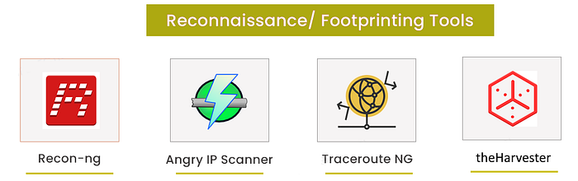

1. [**Recon-ng:**](https://www.kali.org/tools/recon-ng/) Recon-ng is a reconnaissance framework that assists in collecting information from various sources, including online databases and APIs.
2. [**Angry IP Scanner**](https://angryip.org/)**:**Angry IP Scanneris an open-source network scanning tool used to identify live hosts and open ports on a network. It offers customizable scans and is widely utilized by network administrators and security professionals for network reconnaissance and troubleshooting.
3. [**Traceroute NG**](https://www.solarwinds.com/free-tools/traceroute-ng): Traceroute NG, short for “traceroute-next generation,” is an advanced version of the traditional traceroute tool used in network troubleshooting. It offers enhancements like support for IPv6, extended information about network hops, multiple queries, and geographical data, providing more comprehensive insights into network routing and performance issues.
4. [**theHarvester:**](https://www.kali.org/tools/theharvester/) This tool automates the process of collecting email addresses, subdomains, and virtual hosts from public sources.

**Phase 2: Scanning:**



Scanning typically involves the systematic exploration of a target network or system to identify open ports, services, and potential vulnerabilities. This phase is crucial in the ethical hacking process as it provides valuable information for subsequent penetration testing or security assessment activities.

**Approaches applied in Phase 2:**

1. **Port Scanning**: Port scanning is a fundamental technique that involves probing a target system to identify open ports and the services running on them. This information helps ethical hackers understand the attack surface and potential entry points into the target.
2. **Vulnerability Scanning:** Vulnerability scanning tools, such as Nessus or OpenVAS, are used to systematically scan the target for known vulnerabilities in software and services. This technique aids in identifying weaknesses that could be exploited by attackers.
3. **Banner Grabbing:** Banner grabbing is the practice of extracting information from service banners or headers, revealing details about the versions and configurations of services running on open ports. This information assists ethical hackers in identifying potential vulnerabilities and misconfigurations.

**Software applications utilized in Phase 2:**

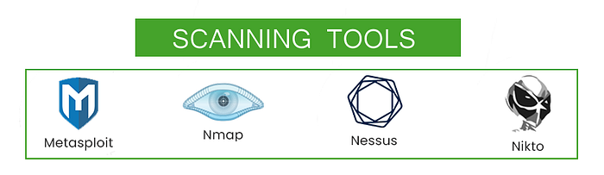

1. [**Metasploit**:](https://www.metasploit.com/) Metasploit is a penetration testing framework that includes various modules for scanning, exploiting, and post-exploitation activities. It’s used to identify and exploit vulnerabilities.
2. [**Nmap (Network Mapper)**](https://nmap.org/): Nmap is a versatile and widely-used open-source tool for network discovery and security auditing. It excels in port scanning, service detection, and OS fingerprinting.
3. [**Nessus**](https://www.tenable.com/products/nessus): Nessus is a powerful vulnerability scanning tool that helps identify known vulnerabilities in target systems and provides detailed reports on potential security issues.
4. [**Nikto**](https://cirt.net/Nikto2)**:** Nikto is an open-source web server and web application scanner that aids cybersecurity professionals in identifying vulnerabilities and security issues. It assesses web servers, checks for known vulnerabilities, inspects web applications for common security flaws, and generates detailed reports to assist in securing online assets.

*“Maybe wars aren’t meant to be won, maybe they’re meant to be continuous.”*

*-from the TV series “Mr. Robot”*

**Phase 3: Gaining Access:**



In Phase 3, ‘Gaining Access,’ ethical hackers engage in a systematic process of exploiting previously identified vulnerabilities. This phase involves executing precise technical actions to gain entry into the target system or network. The goal is to assess the security posture comprehensively by simulating potential attacker techniques. The insights gained guide organizations in strengthening their defenses against real-world cyber threats.

**Methods employed in Phase 3:**

1. **Exploiting Software Vulnerabilities**: Ethical hackers may attempt to exploit known software vulnerabilities in operating systems, applications, or services running on the target system. This can involve techniques like buffer overflows, SQL injection, or remote code execution.
2. **Brute Force Attacks:** Brute force attacks involve systematically trying all possible combinations of usernames and passwords to gain unauthorized access to user accounts or systems.
3. **Credential Theft:** Ethical hackers may attempt to steal credentials through techniques such as phishing, keylogging, or password cracking. Once obtained, these credentials can be used to access the target system.
4. **Pharming and DNS Spoofing:** These techniques involve redirecting network traffic to malicious servers, tricking users or systems into connecting to unauthorized resources.

**Software applications utilized in Phase 3:**

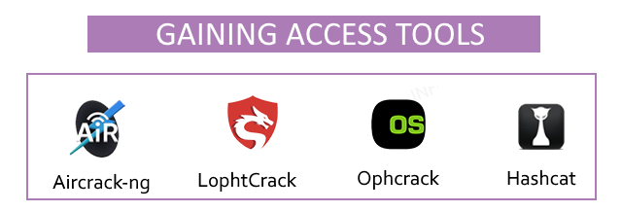

1. [**Aircrack-ng**](https://www.aircrack-ng.org/)**:** Aircrack-ng is a widely-used suite of tools for assessing the security of Wi-Fi networks. It enables security professionals to capture and analyze network traffic, crack encryption keys, and perform various tests to identify vulnerabilities and enhance the security of wireless networks.
2. [**L0phtCrack**](https://l0phtcrack.gitlab.io/)**:** L0phtCrack, or LC5, is a tool used to evaluate the security of Windows passwords. It aids in password recovery and auditing by testing password strength and helping users manage their passwords effectively.
3. [**Ophcrack:**](https://ophcrack.sourceforge.io/) Ophcrack is an open-source password recovery tool that utilizes rainbow tables and advanced algorithms to crack Windows login passwords. It’s frequently employed for technical password recovery and security auditing tasks on Windows operating systems.
4. [**Hashcat:**](https://hashcat.net/hashcat/) Hashcat is a versatile open-source tool known for efficiently cracking password hashes. Security professionals rely on it to assess password security and recover lost or forgotten passwords due to its broad support for cryptographic hash algorithms. Its flexibility and high-performance capabilities make it a valuable asset in cybersecurity assessments.

**Phase 4: Maintaining Access:**

“Maintaining Access,” is a critical stage in ethical hacking where security professionals or penetration testers, having gained initial access to a target system, work to maintain their foothold and establish persistent access. This phase involves various tactics and techniques to ensure continued control over the compromised system or network, replicating real-world attacker persistence to assess the potential risks and impact on the target.

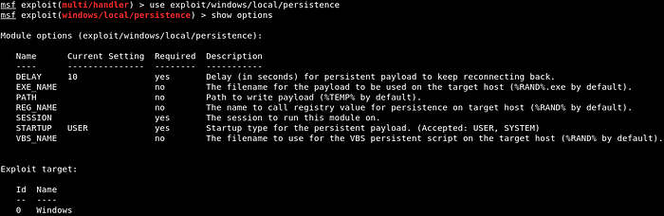

Credits: javatpoint.com

**Strategies employed in Phase 4:**

1. **Backdoors:** Backdoors are hidden entry points or software mechanisms that allow ethical hackers to regain access to a compromised system after initial access has been established. They provide a secret pathway to maintain control.
2. **Privilege Escalation:** Privilege escalation involves elevating user privileges on the compromised system. Ethical hackers seek to gain higher-level access, such as administrative privileges, to control critical resources and systems.
3. **Persistence Scripts:** These are scripts or scheduled tasks created by hackers to run at specific intervals on the compromised system. They ensure that unauthorized access remains intact over an extended period, even if the initial entry point is discovered.
4. **Trojans (Remote Access Tools — RATs):** Trojans or RATs are malicious software programs used to create covert communication channels between the attacker and the compromised system. They enable remote control and data exfiltration.

**Software applications utilized in Phase 4:**

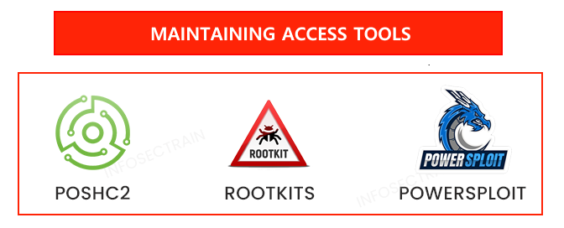

1. [**Poshc2:**](https://github.com/nettitude/PoshC2)POSHC2, or “Posh Command and Control,” is an open-source post-exploitation framework used in cybersecurity. It leverages PowerShell to maintain control over compromised Windows systems, enabling ethical hackers to perform advanced post-exploitation tasks, such as lateral movement and privilege escalation, during security assessments.
2. **Rootkits:** Rootkits are stealthy malicious software that masks their existence on compromised systems by altering core operating system components. They are commonly utilized by cybercriminals to maintain covert, unauthorized access and execute malicious activities. Detecting and removing rootkits demands specialized tools and expertise. Examples of well-known rootkits include:

* **TDSS/TDL Rootkit:** Also known as Alureon, this rootkit infects the Master Boot Record (MBR) and is notorious for its ability to hide from antivirus software.
* **Zeus:**Zeus, or Zbot, is a Trojan that often includes a rootkit component. It specializes in stealing sensitive information, such as banking credentials.
* **Rustock:** The Rustock rootkit was associated with one of the largest spam botnets in the world. It aimed to hide its malicious activity on infected systems.

**3. PowerSploit:** PowerSploit is an open-source framework primarily used in ethical hacking and penetration testing. It employs Microsoft PowerShell to perform various post-exploitation tasks like privilege escalation, data exfiltration, and maintaining access on compromised systems, aiding security professionals in assessing the security of Windows environments.

**Phase 5: Clearing Tracks:**

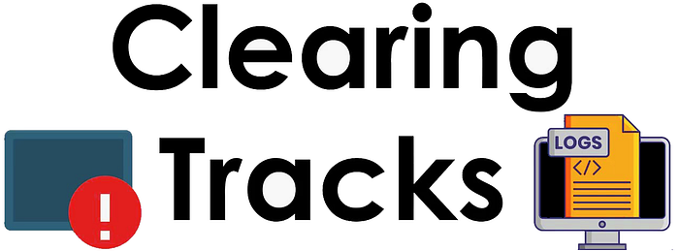

“Clearing Tracks,” is a crucial step in ethical hacking where security professionals, having completed their assessment, take measures to conceal any traces or evidence of their presence and activities on the target system or network. This phase ensures that the ethical hacking engagement remains covert and does not leave any lingering signs of intrusion, protecting the integrity and confidentiality of the assessment.

Approaches implemented in Phase 5:

1. **Log Deletion:** Ethical hackers remove or manipulate log files that may contain records of their activities, ensuring that their actions go unnoticed.
2. **Registry Cleanup:** Entries related to the hacker’s activities in the Windows Registry are removed or altered to erase any signs of intrusion.
3. **Anti-Forensic Techniques:** Techniques to hinder forensic analysis, such as anti-forensic tools or encryption, are employed to make it harder for investigators to reconstruct events.

**Techniques used in phase 5:**

1. L**ogCleaner:** Tools and scripts erase or manipulate log files on a system, removing evidence of the hacker’s actions. For example, they can delete or modify Windows Event Logs like “Security,” eliminating records of login attempts.
2. **Network Traffic Cleaning Tools** (e.g., Scapy): Specialized tools like “Scapy” enable hackers to manipulate network traffic. For instance, Scapy can forge or modify packet headers to obscure communication origins, making it hard for investigators to trace during assessments.
3. **Registry Cleaning Tools:** These Windows-specific applications are used to sanitize and modify the Windows Registry, eliminating or altering entries related to an ethical hacker’s actions to prevent detection.
4. **Anti-Forensic Suites:** Comprehensive toolkits with various utilities designed to erase digital traces, modify metadata, and obstruct forensic investigations, preserving the hacker’s anonymity and activities.

*In today’s ever-evolving cybersecurity landscape, ethical hacking plays a crucial role in safeguarding digital assets. Through meticulous phases and advanced tools, ethical hackers proactively identify vulnerabilities and weaknesses, staying one step ahead of malicious threats. They are the frontline defenders of our digital world, committed to securing our systems and data. As we navigate an increasingly connected world, ethical hacking remains essential in ensuring a secure digital future.*